身分證正面黏貼處 | 身分證反面黏貼處

存摺封面影本

英語能力達標證明

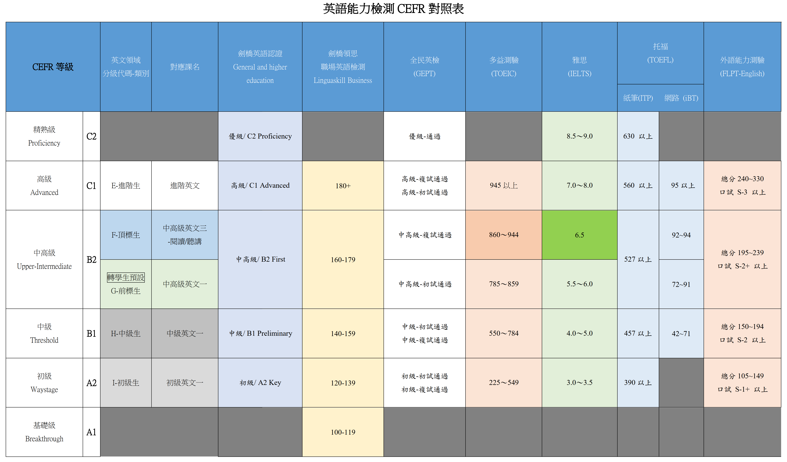
臺北醫學大學收據
Taipei Medical University Payment Receipt
※費用項目  Expense item |  | 英文能力獎勵金 |  |  |  |  |  |  |  |  |  |  | 常見費用項目之所得類別說明：  - 鐘點費、出席費、主持費等-50薪資所得  - 特別演講費、稿費、論文指導費等-9B稿費  - 各項比賽獎金-91競技競賽及機會中獎獎金  - 互助金之各類補助費等-92其他所得  - 入學考試之試務工作費、獎助學金-免稅所得
※領款人姓名
Recipient Name
(as in passport)
連絡電話
TEL
※身分證字號  ID No.  (Alien Resident Certificate) |  |  |  |  |  |  |  |  |  |  |  |  | 外國人士請填寫居留證號碼,若無居留證則依護照資料，前8碼填上西元出生年月日，後2碼填寫所得人英文姓名欄前2個字母。  If recipient doesn’t have ID No. or ARC, please fill in the recipient’s birth date (yyyy/mm/dd) and the first two letters of the recipient’s surname
※身分別  residential status | □居住者  (Resident) | 符合下列條件之一者為居住者：  Any individual who meets one of the following two conditions is considering as “residents”:  - 中華民國境內設有戶籍並領有身分證，並於同一課稅年度居住合計滿 31 天。  Any individual who has Household Registration with ID card and stays in Taiwan (R.O.C.) for 31 days and over in a calendar year.  - 於中華民國境內有住所且居住滿 183 天。  An individual who has no registered residence in the R.O.C. but stays for 183 days or longer is regarded as a R.O.C. resident.
※身分別  residential status | □非居住者  (Non-resident) | 不屬於以上所稱的個人，為非居住者。  Individuals not falling into the above-mentioned categories are regarded as “non-residents of the Republic of China”.
※身分別勾選將影響稅額扣繳率不同，敬請詳實勾選，請詳說明及注意事項第一點。
Please tick residential status carefully, because it will determine your Tax Withholding Rates. You can gather more information in Description and Precautions .
※戶籍地址
Permanent Address
※應 領 金 額  (未扣除稅額及二代健保)  Total Amount Paid |  | 新臺幣 中文大寫金額 元整 ( NTD_______)
帳戶資料  (※限本人帳戶)  Account information |  | □銀行  (Bank) |  |  | 銀行(Bank) 分行(Branch),帳號(A/C No.):
 |  | □郵局  (Post Office) |  |  | 局號帳號(A/C No.):
※受領人簽章  Signature |  | (本人 |  |  |  |  |  |  |  |  |  |  | 簽收日期  Date | / /  (YYYY/MM/DD)
用途說明  instructions |  | 114學年度醫學工程學院雙語計畫英語能力達標 □B1 □B2 □C1 □C2獎勵金
說明及注意事項Description and Precautions：
- 非居住者所得稅：
1.薪資所得：
110年1月1日起全月薪資所得給付總額36,000元以下者扣取6%稅額，36,001元以上者扣取18%稅額，請於給付時先行預扣稅額。(※扣繳之稅額若有小數點，無條件捨去！)
According to Standards of Withholding Rates for Various Incomes and the stipulation of monthly basic wage , non-resident withholding rate is 6%, in the case of salaries in full amount not exceeding 1.5 times the monthly basic salary (NTD 36,000); if not, 18％of the payment is withheld starting on Jan.1, 2021.
2.非屬薪資所得之其他各類所得：
依每次給付所得總額扣取20%稅額，若屬個人稿費、版稅等執行業務所得，每次給付不超過新台幣5,000元者免扣繳，但仍應依非居住者於規定期限內列單申報。
For remuneration to professional practitioners, 20% of the payment is withheld. However, income derived from written articles, copyrighted books, musical compositions, musical productions, dramas, cartoons, or as remuneration for speeches and lectures on an hourly basis, for which each payment does not exceed NT$5,000, may be exempted from tax.
- 各單位經辦人：
1.急件辦理：
各單位經辦人支付「非居住者」所得（以收據簽收日起算），請使用急件辦理。
2.3日內備妥相關資料送財務處：
各單位經辦人請於3日內將①簽收收據、②護照或居留證或身分證影本及③會2付款憑單等相關資料送財務處登帳，出納組始得於10日內向國庫繳清稅款且向國稅局完成申報作業【注意：如不扣稅，仍需檢附前揭資料供出納組向國稅局申報該所得】，避免逾期繳納稅款及申報作業而衍生罰鍰（所得稅法第 111 條），如逾期繳交申報，衍生之稅責問題，由各經辦單位自行負責。

